Emergency Notifier Using Android Studio

Keerthana T.¹
tkeerthana1999@gmail.com
Pujah B. ²
pujahbalasubramaniam.55@gmail.com

^{1,2} Department of Information Technology
Meenakshi Sundararajan Engineering College
Chennai,India

Abstract — Security for women has become a major issue as the number of crimes over women and girls increasing day-by-day. The safety of women & children is a concern of increasing urgency in India and other countries. The primary issue in the handling of these cases by the police lies in constraints preventing them from responding quickly to calls of distress. These constraints include not knowing the location of the crime, and not knowing the crime is occurring at all: at the victim's end, reaching the police assuredly and discreetly is a challenge. To aid in the removal of these constraints, this paper introduces a mobile application called Panic Button that provides not only women & children with a reliable way to send an emergency message to anyone. A message containing the geographical location of the user along with the latitude and longitude details will be immediately sent to the contact selected. This message is sent via the SMS. This application can be used with and without your mobile data connection. This paper describes the application, its development, and its technical implementation. Whenever somebody is in trouble They Only have to press this panic button. After that a message alert is sent to the selected contact from the contact list and give a message “HELP I AM IN DANGER & I AM AT THIS ADDRESS→” including your current location and its latitude and longitude value.
Keywords — Women & children security, Smartphone, Any contact, GPS (Global Positioning System)

Introduction
This application designed to provide security to women main purpose of this application to provide the awareness on the time of critical situation for women. Generally you can active this service by clicking on ACTIVE SERVICE button. Security for women has become a major issue as the number of crimes over women and girls increasing day-by-day. The safety of women & children is a concern of increasing urgency in India and other countries. The primary issue in the handling of these cases by the police lies in constraints preventing them from responding quickly to calls of distress. These constraints include not knowing the location of the crime, and not knowing the crime is occurring at all: at the victim's end, reaching the police assuredly and discreetly is a challenge.
To aid in the removal of these constraints, this paper introduces a mobile application called Panic Button that provides not only women & children with a reliable way to send an emergency message to anyone. A message containing the geographical location of the user along with the latitude and longitude details, will be immediately sent to the contact selected. This message is sent via the SMS. This application can be used with and without your mobile data connection. This paper describes the application, its development, and its technical implementation.
Whenever somebody is in trouble They Only have to press this panic button. After that a message alert is sent to the selected contact from the contact list and give a message “HELP I AM IN DANGER & I AM AT THIS ADDRESS→” including your current location and its latitude and longitude value.

SYSTEM DESIGN
- Existing System
Keeping the same concern in mind many developers have come up with innovative applications. Few of such applications are as follows
VithU App: This is an emergency app initiated by a popular Indian crime television series “Gumrah” aired on Channel. In this app when the power button of the Smartphone is pressed twice consecutively, it will begin sending out alert messages with a link to the location of the user every two minutes to the contacts fed into the app.
SHE (Society Harnessing Equipment): It is a garment designed by three engineers from Chennai. This garment has an electric circuit that can generate 3800kv of current which can help the victim to escape.In case of multiple attacks it can send upto 82 electric shocks. Since the fabric is bilayer, the user is not affected. It can also send emergency messages.
- Proposed System
The proposed system is especially for the women safety and overcomes the disadvantages of existing system:- This proposed system is ‘ GPS Based women Security System’. It consists of GPS device ie. Any Android Phone and an emergency button. GPS device must to be placed inside the device (Android Phone). The device will provide the position information such as latitude, longitude of women. An emergency button is fixed on the device at a particular position. Whenever women in any kind of trouble she will press the emergency button and an alert will be immediately sent to the selected contact. Then it is the responsibility of police squad to handle the situation. Features
1) This project presents an alert system for Women safety detection.
2) The system provides a realizable and efficient.
3) The application is easier to use all the woman & others too.
4) The application is normal budget.
5) For user there is no need of external hardware or software to use this application
6) This application is free for user, which does not affect user’s cost
7) User only need a Smartphone or tablet which has Android OS to the work.
C. Data flow diagram

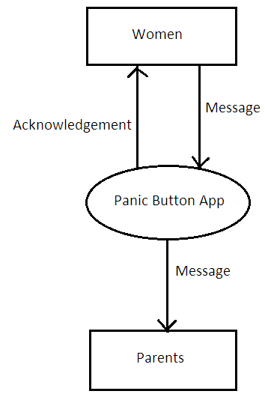

APPLICATION WORKING
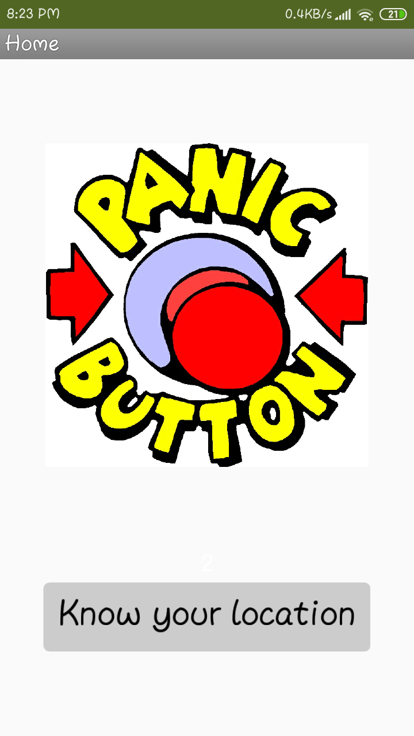
Figure (1): Home Screen of the App
This is the home screen of the application. It contains of two buttons. One is a contact picker and the other is a navigation button.
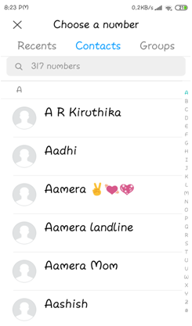
Figure (2): List if contacts
When the panic button is pressed, it takes you to your contacts from which you can choose a contact to send your message via SMS or telecast the message via an existing contact group.
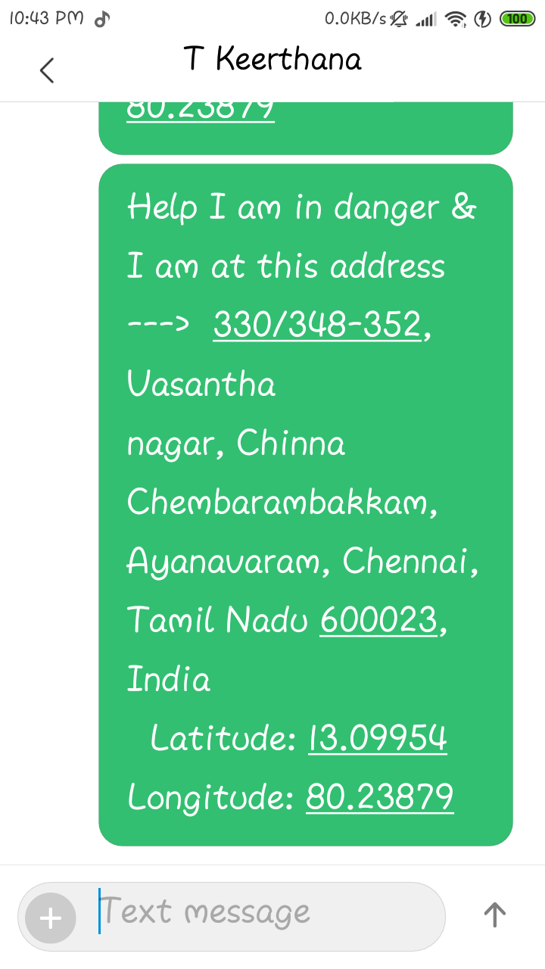
Figure (3): Sample Message (with internet)
When you choose acontact or a group you will get a pre – typed message stating that you are in danger which includes you current location with its latitude and longitude values
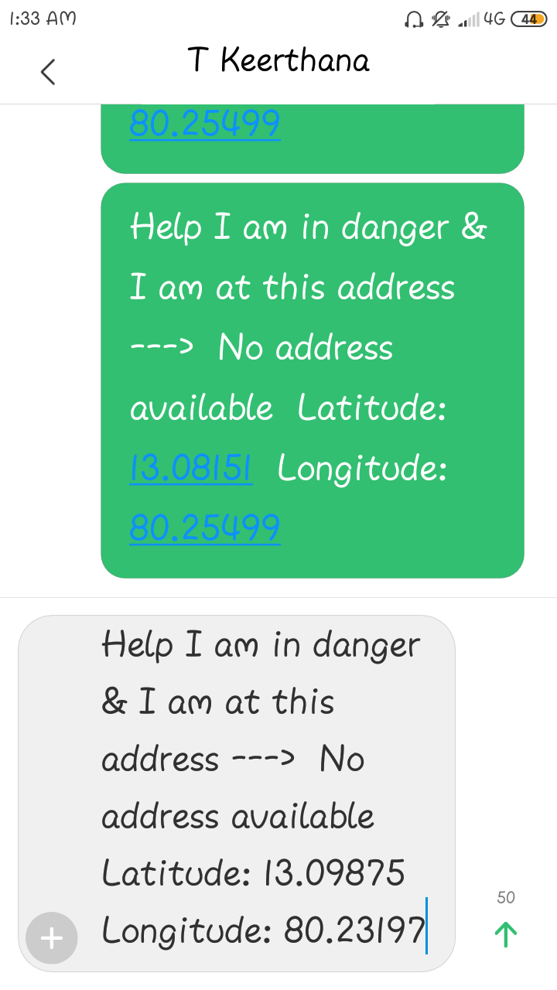
Figure (4): Sample Message (without internet)
Suppose that you do not have an internet connection you need not worry as this application also works without the internet connection. (i.e. It only shares the latitude and longitude details).
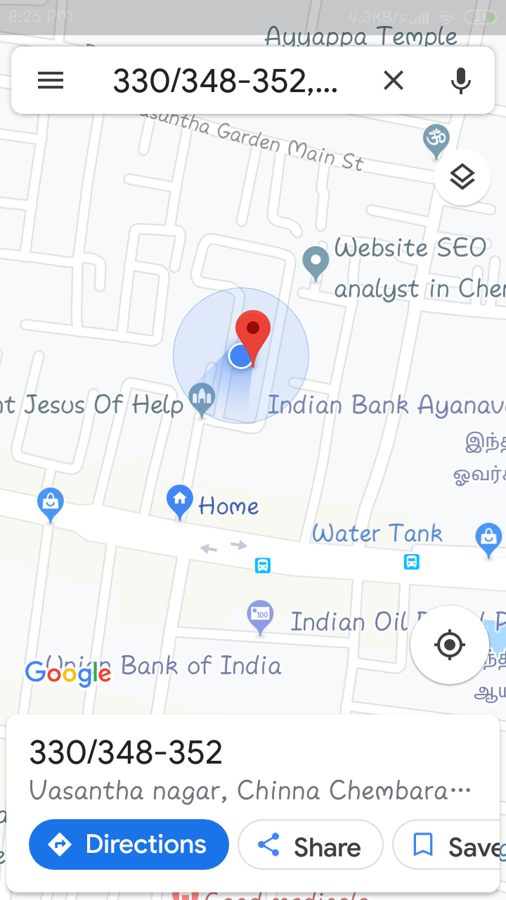
Figure (5): Checking of location
We checked the address with the google map and it shows that the address is my exact current location. Here the small blue coloured light shows my current location on google maps and the red marker shows the location of the address searched for whish is exactly my current location
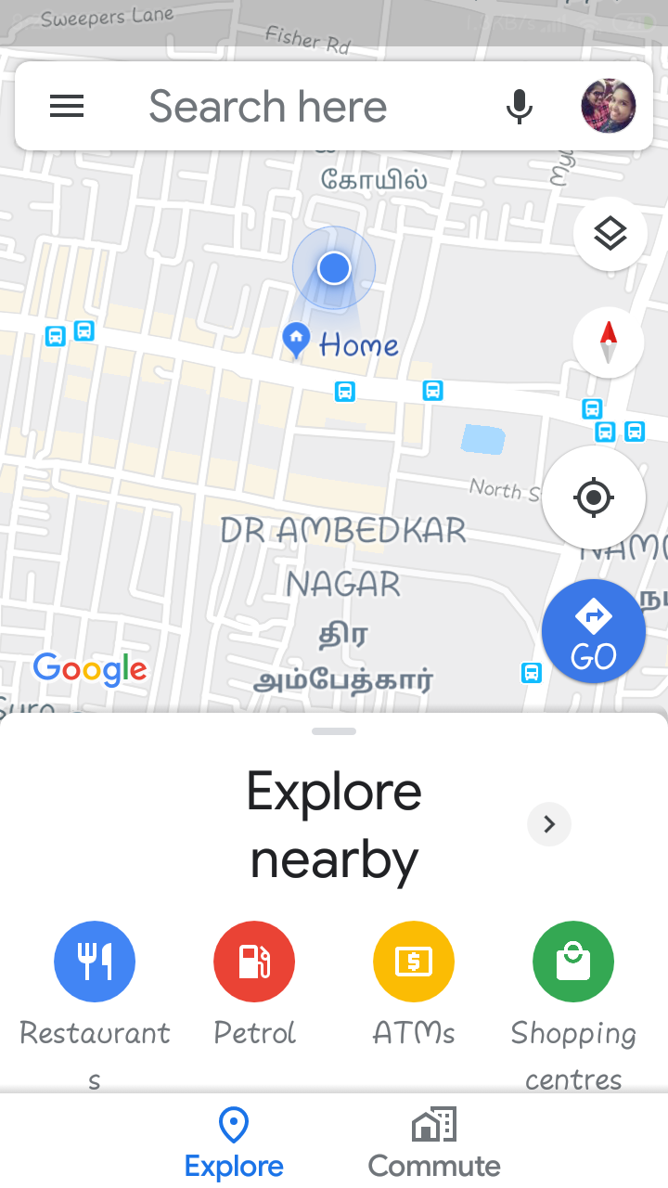
Figure (6): Button 2
When we click on the othe rbutton on the home screen (i.e. Know your location) , It shows your exact location on google maps.

IMPLEMENTATION AND METHODOLOGY

Software Requirement:
This system compromises an Android Operating System, using Java has a core language, with Android SDK 2.3 has its version, the documentation of this system is done using MS-Office.

Java Platform:
A platform is the hardware or software environment in which a program runs. The Java platform differs from most other platforms in that it's a software-only platform that runs on top of other, hardware-based platforms. Most other platforms are described as a combination of hardware and operating system. The Java platform has two components: The Java Virtual Machine (Java VM) and The Java Application Programming Interface (Java API) Java VM is the base for the Java platform and is ported onto various hardware-based platforms. The Java API is a large collection of ready-made software components that provide many useful capabilities, such as graphical user interface (GUI) widgets. The Java API is grouped into libraries (packages) of related components. The following figure of Java Structure depicts a Java program, such as an application or applet, that's running on the Java platform. As the figure shows, the Java API and Virtual Machine insulates the Java program from hardware dependencies.

Android SDK –API 23:
Android is an operating system based on Linux with a Java programming interface. The Android Software Development Kit (Android SDK) provides all necessary tools to develop Android applications. This includes a compiler, debugger and a device emulator, as well as its own virtual machine to run Android programs. Android is primarily developed by Google. Android allows background processing, provides a rich user interface library, supports 2-D and 3-D graphics using the OpenGL libraries, access to the file system and provides an embedded SQLite database. Android application consists of different components and can reuse components of other applications. This leads to the concept of a task in Android; an application can re-use other Android components to archive a task.

Android Development Tools:
Android is a widely anticipated open source operating system for mobile devices that provides a base operating system, an application middleware layer, a Java software development kit (SDK), and a collection of system applications. Android mobile application development is based on Java language codes, as it allows developers to write codes in the Java language as illustrated in the below architecture figure of Android structure. Android operating system is a stack of software components which is roughly divided into five sections and four main layers as shown below in the architecture diagram

CONCLUSION
The problem of the women safety is increased rapidly in this environment, so I proposed as an effective Android application to prevent such type of the suspicious or natural disaster, by alerting the concern authorities using the android mobile phone which helps to stop such type of illegal activates and to trace the concern.
Scope: The scope of this project is very broad in terms of other tracking system. It is online as well as offline system. This can be used for the insecurity of women. It helps to efficiently increase the security and safety of women’s.
REFERENCES
[1] Android Programming Tutorials by Mark L. Murphy
[2] Akshata V.S.1, Rumana Pathan2, Poor nima Patil3 and Farjana Nadaf4 , B’Safe & B’Secure The Door to Safety Swings, Department of Computer Science Engineering, KLS’s VDRIT, Haliyal, India, (IJCEM), ISSN: 2348 9510 Volume 1, Issue 7, October 2014
[3] S.Sangeetha1,P.Radhika PG scholar, Application For Women Safety,Department Of MCA, Panimalar Engineering College,IOSR,ISSN:2278-0661,pISSN:2278-8727, Volume 17,ISSUE 3, Ver.IV(May-Jun.2015),pp01-04.
[4] http://en.wikipedia.org/wiki/andorid
[5] Android Based Safety Triggering Application P.Kalyanchakravarthy1, T.Lakshmi2 ,R.Rupavathi2, S.Krishnadilip2, P.Lakshmankumar2,Assitant Professor1, BTech Student CSE Department, Lendi Institute Of Engineering & Technology,Affilitated by, JNTUK,Jonada, Vizayanagaram, Andhra Pradesh, India, IJCSIT , ISSN: 0975-9646,Vol. 5(1),2014,646-647.
[6] Bramarambika Thota , Udaya Kanchana Kumar .P, Sauver: An Android Application For Women Safe-ty, MTech , Dept.Of ECE ,Vignan University , Guntur , India , M.sc , Computer Science , TJPS College, Guntur,India ,IJTEEE ,ISSN:2347-4289.VOL 3,ISSUE 05.

